Jasmina Durmishi – Collaboration Diagrams

CD_LMS_27 - Send Due Date Reminder:
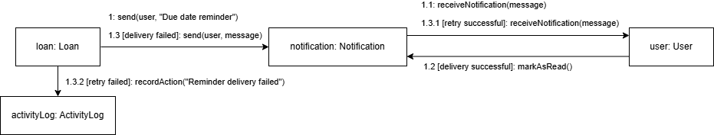

CD_LMS_28 - Send Overdue Notification:
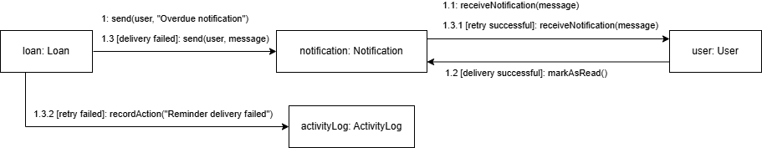

CD_LMS_29 - Send Borrowing Confirmation:
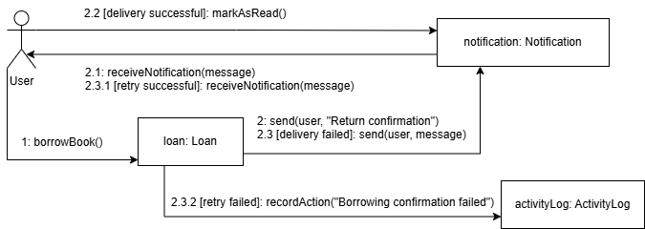

CD_LMS_30 - Send Return Confirmation: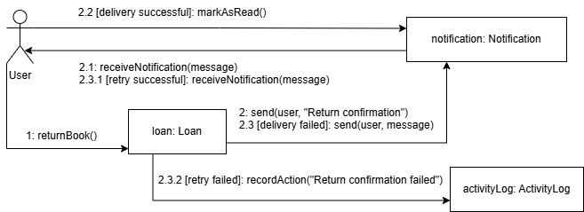

CD_LMS_31 - Send Fine Notification:
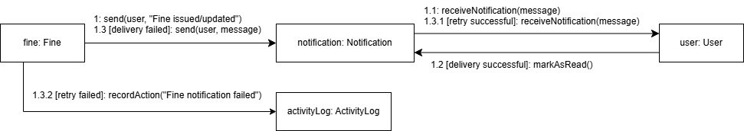

CS_LMS_32 - Deliver Alerts and Announcements:
